Stored Procedure Exercise 1: Create a Stored Procedure

CREATE DATABASE CompanyDB;
GO
USE CompanyDB;
GO
CREATE TABLE Department
(
DepartmentID INT PRIMARY KEY,
DepartmentName VARCHAR(50)
);
CREATE TABLE Employee
(
EmployeeID INT PRIMARY KEY,
EmployeeName VARCHAR(50),
DepartmentID INT,
Salary DECIMAL(10,2),
HireDate DATE,

FOREIGN KEY (DepartmentID)
REFERENCES Department(DepartmentID)
);
INSERT INTO Department VALUES
(1,'IT'),
(2,'HR'),
(3,'Finance'),
(4,'Marketing');
SELECT * FROM Department;

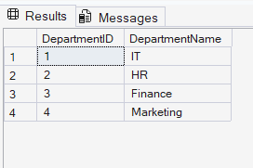
INSERT INTO Employee VALUES
(101,'Rahul',1,65000,'2022-01-10'),
(102,'Sneha',2,48000,'2021-03-15'),
(103,'Kiran',1,72000,'2020-08-12'),
(104,'Akash',3,58000,'2019-12-20'),
(105,'Divya',4,52000,'2023-02-18'),
(106,'Nikhil',1,81000,'2018-05-30'),
(107,'Anjali',2,51000,'2022-11-11'),
(108,'Vikas',3,69000,'2021-07-09');

SELECT * FROM Employee;
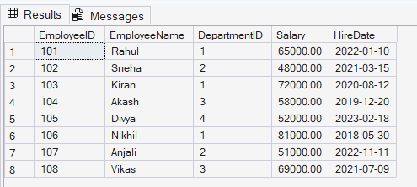
CREATE PROCEDURE GetEmployeesByDepartment
@DeptID INT
AS
BEGIN

SELECT
EmployeeID,
EmployeeName,
Salary,
HireDate
FROM Employee

WHERE DepartmentID=@DeptID;

END;
GO
EXEC GetEmployeesByDepartment 1;
